Lab3

Wenhao He

# Boxes of water

## Report the instantaneous and averaged pressure, temperature, and density over your production run of NPT dynamics for TIP3P and TIP4PFB water models. Graph the instantaneous data. Recall in class that we said that pressure was not well-defined for such small systems but that a smooth density was a better measure. Does your data agree?

Yes, my data agrees well with the statement. In the figure, we can see that the fluctuation of pressure is far larger than its average value, it is not well defined. But density is relatively smooth.

|  |  |  |
| --- | --- | --- |
| Water Model | TIP3P | TIP4PFB |
| Average Pressure | -5.6556 | -5.5233 |
| Average Temperature | 298.08 | 297.91 |
| Average Density | 0.9849 | 0.9968 |

TIP3P instanteneous results:

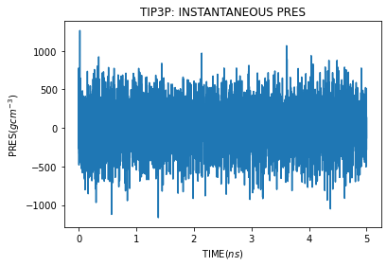 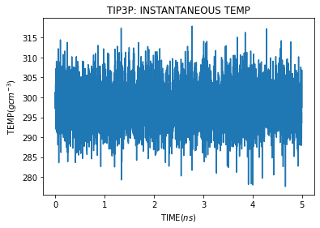 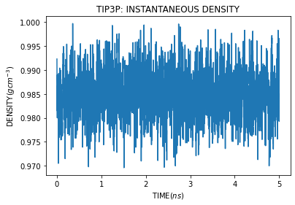

TIP4PFB instanteneous results:

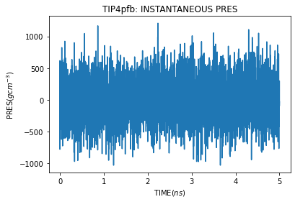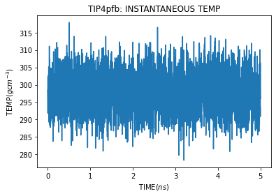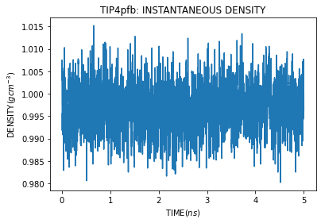

# Calculate the self-diffusion coefficient of liquid water for TIP3P and TIP4PFB. Report these in cm2/s. Note that the units AMBER uses are ps and Å.

|  |  |  |
| --- | --- | --- |
| method | TIP3P | TIP4PFB |
| Self-diffusion coefficient | $$5.22×{10}^{-5}$$ | $$1.82×{10}^{-5}$$ |

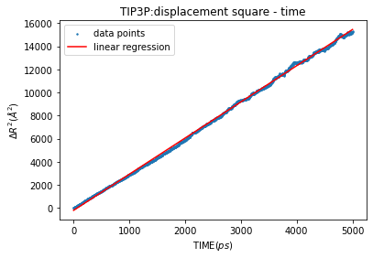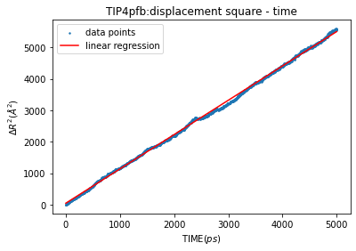

## Report the O-O radial distribution function from these simulations – overlay the results from all the different water models. Comment on any differences. Determine the average number of nearest-neighbor water molecules by integrating the curve and obtaining the value at the first minimum in the curve.

Tip3pfb has a shapper peak and valley than Tip3p, they approach the same value when r reaches infinite. r value corresponding to first peak are almost the same.But for first valley, second peak, second valley…, Tip4pfb corresponds to smaller r than Tip3p, which means that Tip4pfb radial distribution function oscillates faster than Tip3p

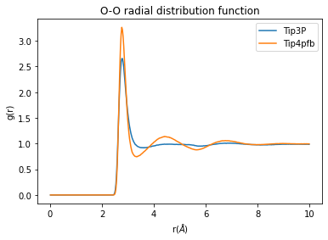

|  |  |  |
| --- | --- | --- |
| method | TIP3P | TIP4PFB |
| Number of nearest | 5.749 | 4.503 |

## Plot the number of hydrogen bonds between a single water molecule and the others during the NPT production run for each water model. On average, how many hydrogen bonds are formed per water molecule? What are the average lengths and angles of these bonds? Do they differ between the two water models?

There are two types of H bonds. First is the O atom of this single molecule and H atom of other molecules:

|  |  |  |
| --- | --- | --- |
| Case 1 | TIP3P | TIP4PFB |
| Average H bonds number | 1.2792 | 1.5104 |
| Average length | 2.7936 | 2.7957 |
| Average angle | 159.68 | 161.36 |

Second is the O atom of this single molecule and H atom of other molecules:

|  |  |  |
| --- | --- | --- |
| Case 2 | TIP3P | TIP4PFB |
| Average H bonds number | 0.6574 | 0.7804 |
| Average length | 2.7990 | 2.8011 |
| Average angle | 158.7918 | 161.12 |

It terms out that the average results are different for two models

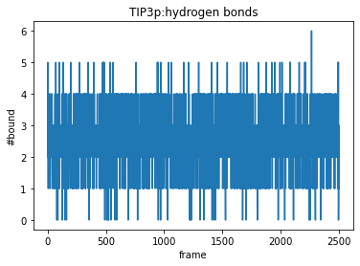 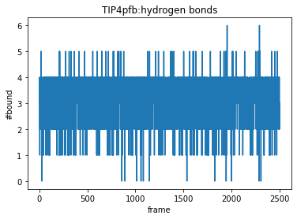

# Salt solution

## Report the Mg-O radial distribution function for the TIP3P water model. Identify the number of water molecules in the first solvation shell of Mg2+ and the second solvation shell via the integrated RDF. Compare the Mg-O RDF to that for the Cl-O RDF. What do the differences for Mg2+ vs. Cl- tell you about exchange events between first solvation shell waters and the environment in the two environments?

number of water molecules in the first solvation shell:

Mg2+ : 6.00

Cl-: 7.39

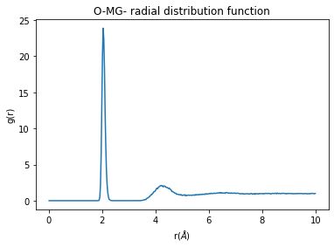

This tells us that Cl- has more exchange events. Regarding that Cl- has less charge(1e vs 2e), maybe negative ions has more exchange events.

## Assuming we instead compute the Mg-H and Cl-H RDF, how do you expect these to differ from the Mg-O and Cl-O RDFs (and from each other)? What does this imply about the orientation of water relative to the ions?

I will expect that radial distribution function curve for Mg-H will has a r positive direction shift than Mg-O, while Cl-H will has a r negative direction shift than Cl-O. This tells us that O atom of water tends to opposite to a negative ion, and H part of water tends to attractive to a negative ion. The case is opposite for positive ion. This tells us that same charge opposite, and different charge attractive.

## Use cpptraj and the watershell command to identify the number of waters in each solvation shell of the Mg and Cl ions. Plot these numbers throughout the duration of the simulation. Compare this to the number identified in question 5 via the RDF and comment on the utility of the watershell command.

For Mg, we have

|  |  |  |
| --- | --- | --- |
| method | watershell | RDF |
| Within Shell 1 | 6.000 | 6.000 |
| Within shell 2 | 21.270 | 21.326 |

For Cl, we have

|  |  |  |
| --- | --- | --- |
| method | watershell | RDF |
| Within Shell 1 | 7.354 | 7.388 |
| Within shell 2 | 31.627 | 31.948 |

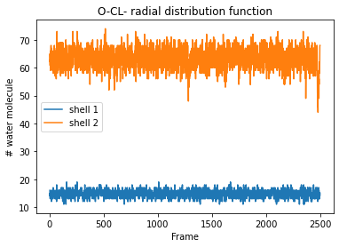 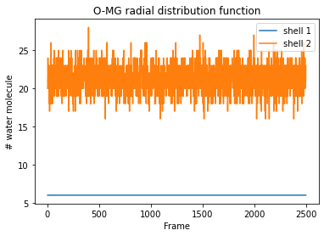

# Charges

### Compare the charges obtained from AM1-BCC to the charges you learned about for TIP3P water in class. Are they in close agreement or do they disagree? How does the AM1-BCC charge on oxygen in methanol compare to that in water? What about the hydroxyl hydrogen on methanol versus the hydrogen in water?

|  |  |  |
| --- | --- | --- |
|  | H2O | methanol |
| O | -0.785000 | -0.598800 |
| H | 0.392000 | 0.028700 |
| H1 | 0.392000 | 0.028700 |

Results agree well.